Students of the Month for March 2017

7th Jami Hasty
8th Paxton Nichol
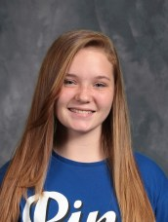

9th Hannah McCaig
10th Bobbi Jo Hahn

11th Kayla Clark
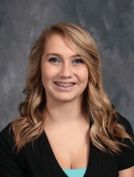
12th Mayzie Thompson

